Министерство образования Республики Беларусь

Учреждение образования

БЕЛОРУССКИЙ ГОСУДАРСТВЕННЫЙ УНИВЕРСИТЕТ

ИНФОРМАТИКИ И РАДИОЭЛЕКТРОНИКИ

Факультет компьютерных систем и сетей

Кафедра программного обеспечения информационных технологий

Дисциплина: Разработка программного обеспечения для мобильных платформ

ОТЧЕТ

По лабораторной работе №3

Тема работы: «QR-считыватель/ генератор»

Выполнил:

студент: гр. 051006 Шуляк А.В.

Проверил: Коловайтис Н. А.

Минск 2023

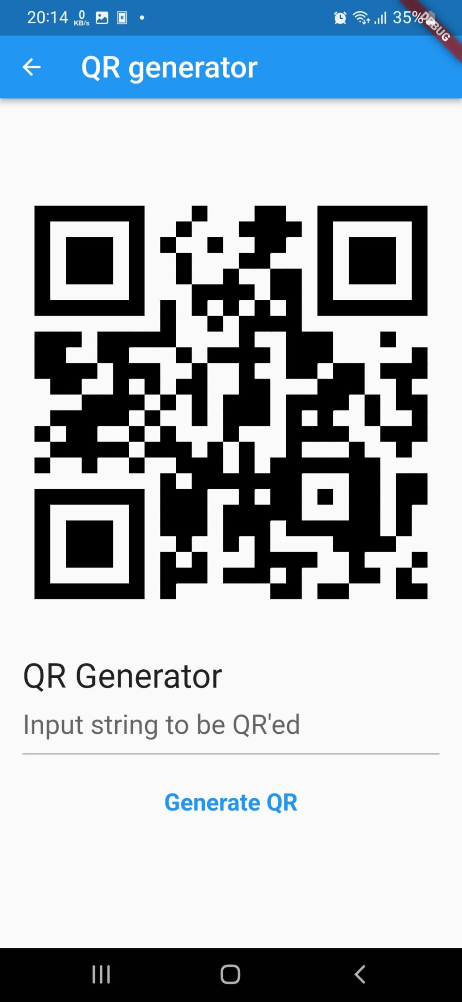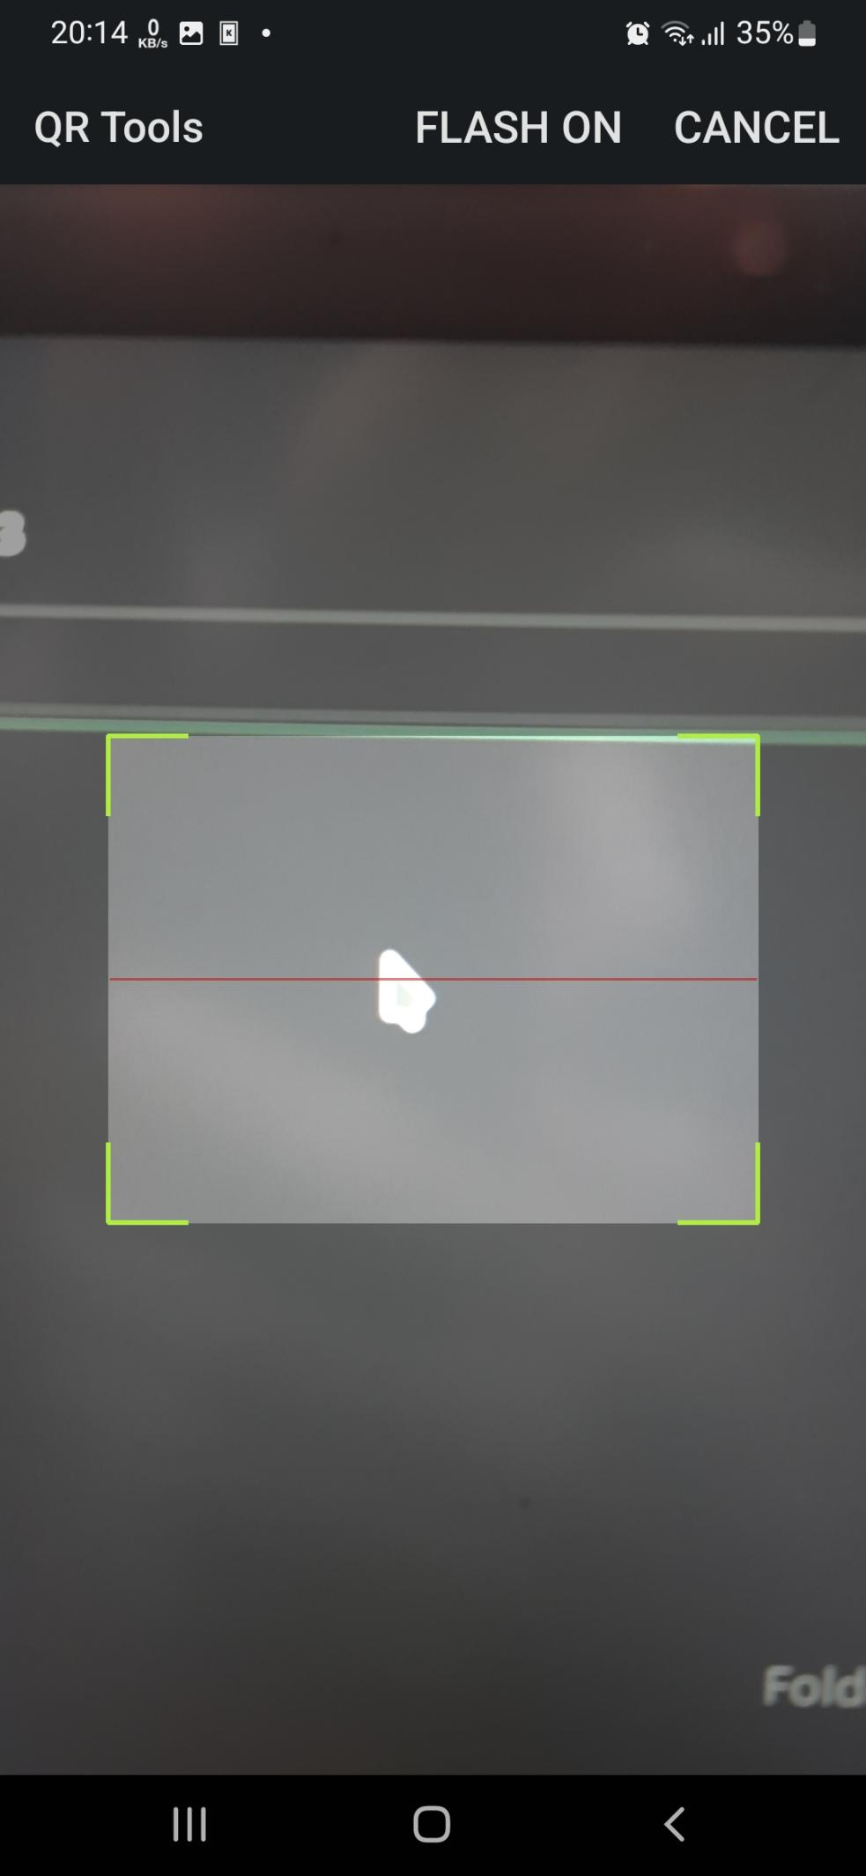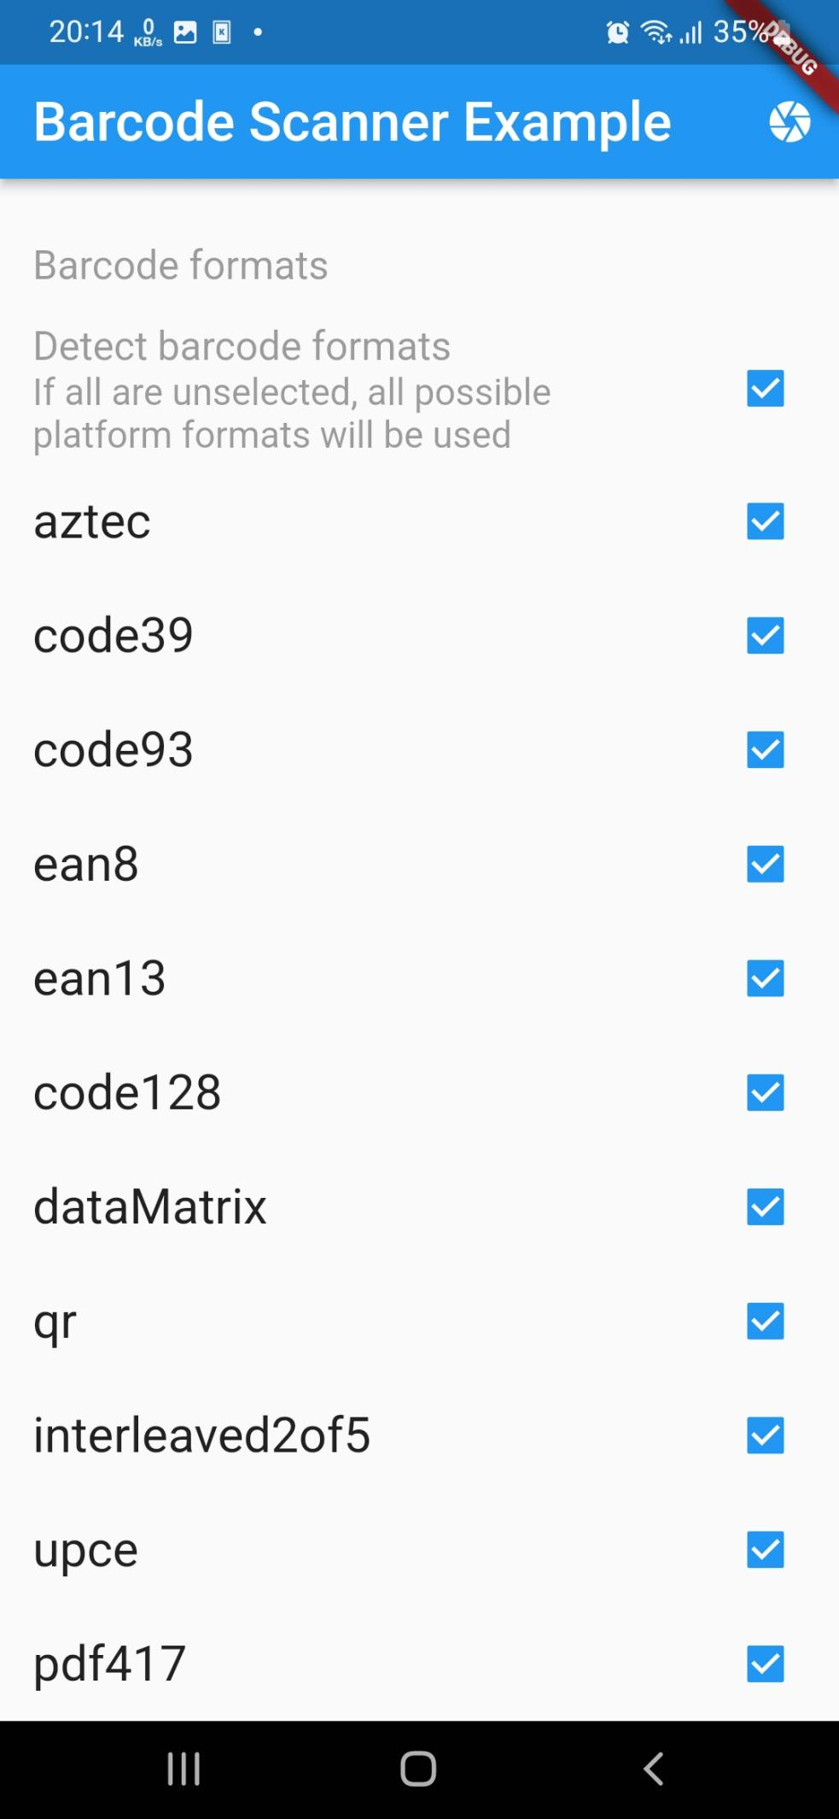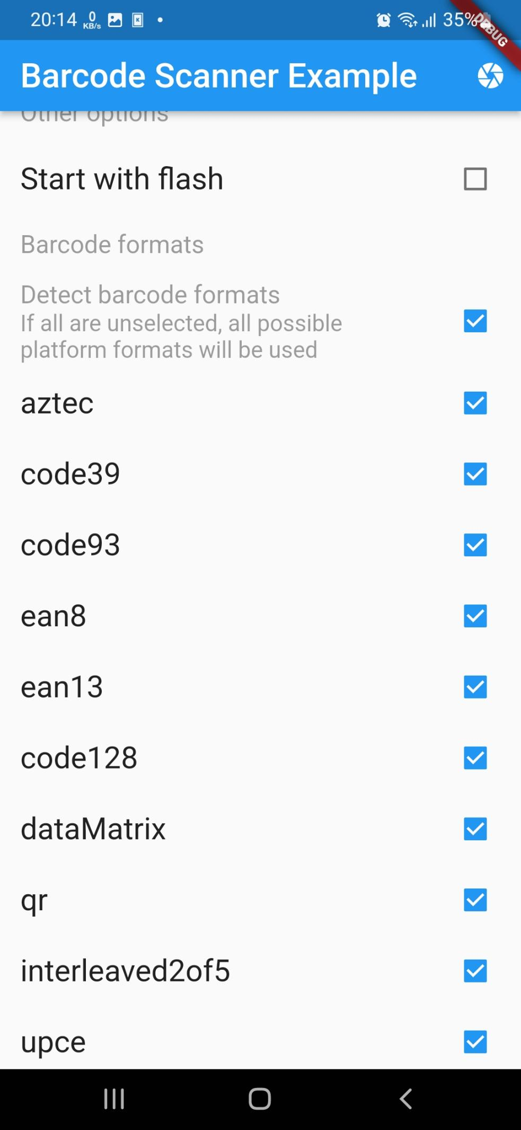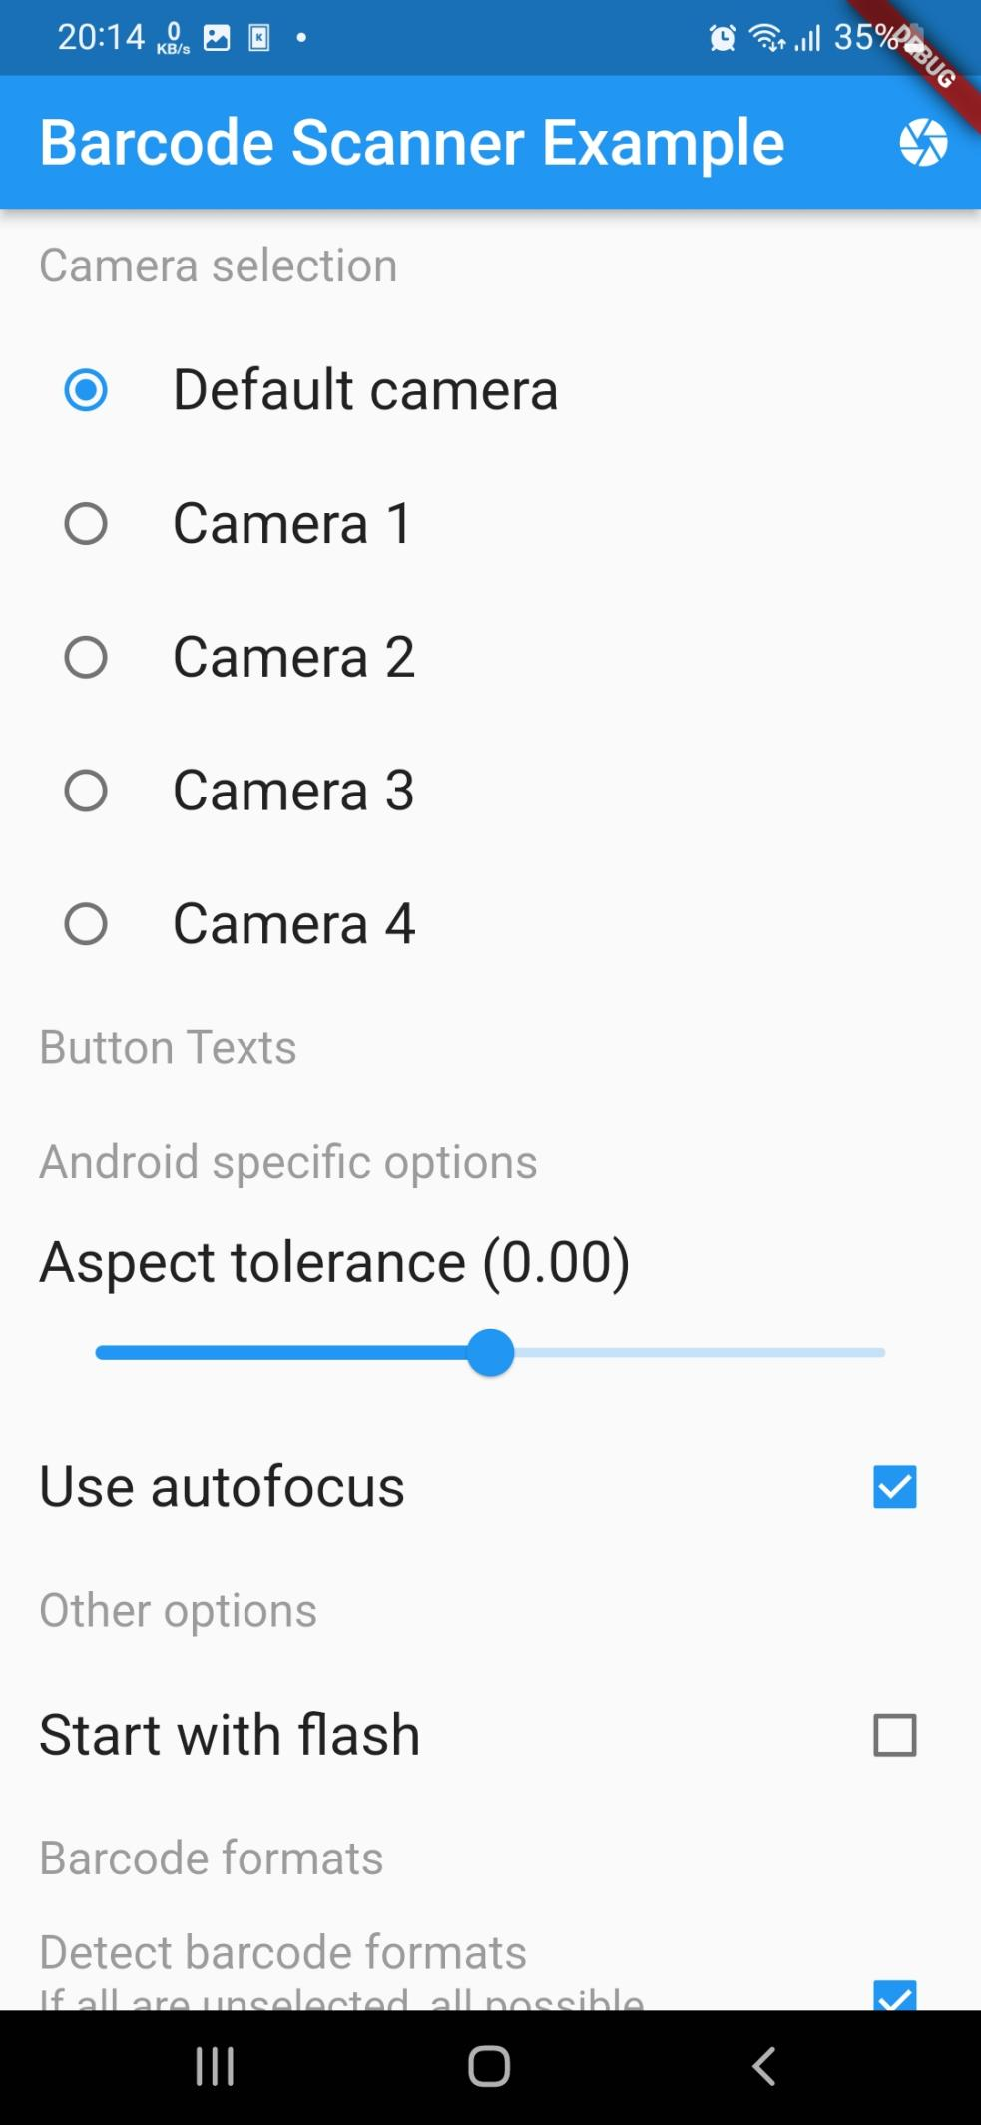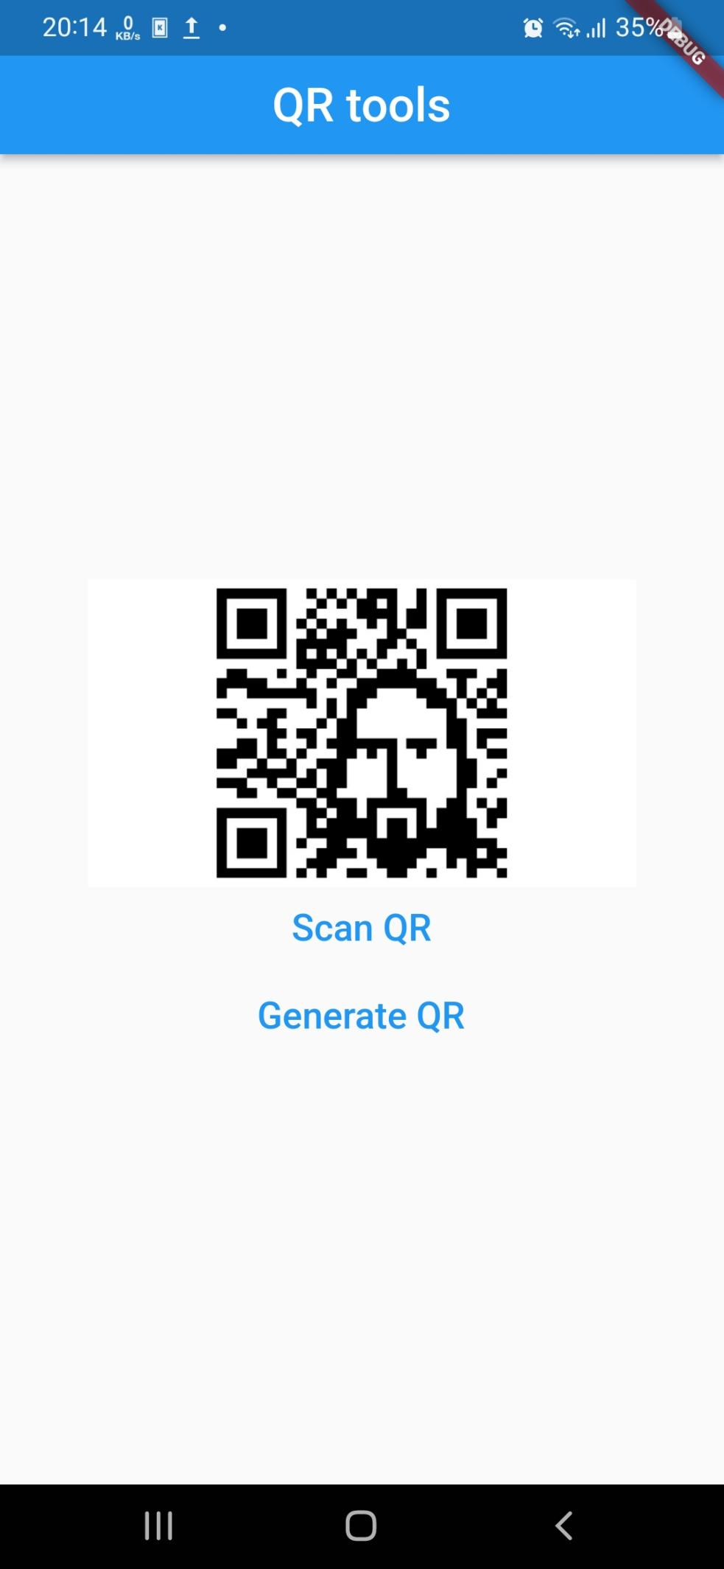

Исходный код:

main.dart:

import 'package:flutter/material.dart';

import 'package:qr_tools/home.dart';

void main() {

runApp(const MyApp());

}

class MyApp extends StatelessWidget {

const MyApp({super.key});

@override

Widget build(BuildContext context) {

return MaterialApp(

title: 'Flutter Demo',

theme: ThemeData(

primarySwatch: Colors.blue,

),

home: Home(),

);

}

}

home.dart:

import 'package:flutter/material.dart';

import 'package:qr_tools/generate.dart';

import 'package:qr_tools/scan.dart';

class Home extends StatefulWidget {

const Home({super.key});

@override

State<Home> createState() => _HomeState();

}

class _HomeState extends State<Home> {

@override

Widget build(BuildContext context) {

return Scaffold(

appBar: AppBar(

title: const Text("QR tools"),

centerTitle: true,

),

body: Container(

padding: const EdgeInsets.all(50.0),

child: Column(

mainAxisAlignment: MainAxisAlignment.center,

crossAxisAlignment: CrossAxisAlignment.stretch,

children: <Widget>[

const Image(

image: NetworkImage(

"http://www.rocketfarmstudios.com/wp-content/uploads/2015/08/wallpaper_qr_code_jesus_by_existcze-d5krc2g.jpg")),

textButton("Scan QR", ScanPage()),

const SizedBox(

height: 2.0,

),

textButton("Generate QR", GeneratePage()),

],

)));

}

Widget textButton(String text, Widget widget) {

return TextButton(

onPressed: () {

Navigator.of(context)

.push(MaterialPageRoute(builder: ((context) => widget)));

},

child: Text(text),

);

}

}

scan.dart:

import 'dart:async';

import 'dart:developer';

import 'dart:io' show Platform;

import 'package:barcode_scan2/barcode_scan2.dart';

import 'package:flutter/material.dart';

import 'package:flutter/services.dart';

import 'package:url_launcher/url_launcher.dart';

class ScanPage extends StatefulWidget {

const ScanPage({super.key});

@override

State<ScanPage> createState() => _ScanPageState();

}

class _ScanPageState extends State<ScanPage> {

ScanResult? scanResult;

final _flashOnController = TextEditingController(text: 'Flash on');

final _flashOffController = TextEditingController(text: 'Flash off');

final _cancelController = TextEditingController(text: 'Cancel');

var _aspectTolerance = 0.00;

var _numberOfCameras = 0;

var _selectedCamera = -1;

var _useAutoFocus = true;

var _autoEnableFlash = false;

static final _possibleFormats = BarcodeFormat.values.toList()

..removeWhere((e) => e == BarcodeFormat.unknown);

List<BarcodeFormat> selectedFormats = [..._possibleFormats];

@override

void initState() {

super.initState();

Future.delayed(Duration.zero, () async {

_numberOfCameras = await BarcodeScanner.numberOfCameras;

setState(() {});

});

}

bool _isUrl(String text) {

final urlRegex = RegExp(

r'^((?:http|https):\/\/)?([a-zA-Z0-9-]+(?:\.[a-zA-Z0-9-]+)*\.[a-zA-Z]{2,})(?::\d{1,5})?(\/[^\s]*)?$');

var res = urlRegex.hasMatch(text);

log("url is $res");

return res;

}

_launchUrl(String url) async {

var uri = Uri.parse(url);

if (_isUrl(url)) {

await launchUrl(uri, mode: LaunchMode.externalApplication);

}

}

void _copyToClipboard(String text) {

Clipboard.setData(ClipboardData(text: text));

ScaffoldMessenger.of(context).showSnackBar(const SnackBar(

content: Text('Copied to clipboard'),

));

}

@override

Widget build(BuildContext context) {

final scanResult = this.scanResult;

return MaterialApp(

home: Scaffold(

appBar: AppBar(

title: const Text('Barcode Scanner Example'),

actions: [

IconButton(

icon: const Icon(Icons.camera),

tooltip: 'Scan',

onPressed: _scan,

)

],

),

body: ListView(

shrinkWrap: true,

children: <Widget>[

if (scanResult != null)

Card(

child: Column(

children: <Widget>[

ListTile(

title: const Text('Result Type'),

subtitle: Text(scanResult.type.toString()),

),

ListTile(

title: const Text('Raw Content'),

// subtitle: Text(scanResult.rawContent),

subtitle: TextButton(

onPressed: () {

log("log: ${scanResult.rawContent}");

_copyToClipboard(scanResult.rawContent);

_launchUrl(scanResult.rawContent);

},

child: Text(scanResult.rawContent),

),

),

ListTile(

title: const Text('Format'),

subtitle: Text(scanResult.format.toString()),

),

ListTile(

title: const Text('Format note'),

subtitle: Text(scanResult.formatNote),

),

],

),

),

const ListTile(

title: Text('Camera selection'),

dense: true,

enabled: false,

),

RadioListTile(

onChanged: (v) => setState(() => _selectedCamera = -1),

value: -1,

title: const Text('Default camera'),

groupValue: _selectedCamera,

),

...List.generate(

_numberOfCameras,

(i) => RadioListTile(

onChanged: (v) => setState(() => _selectedCamera = i),

value: i,

title: Text('Camera ${i + 1}'),

groupValue: _selectedCamera,

),

),

const ListTile(

title: Text('Button Texts'),

dense: true,

enabled: false,

),

if (Platform.isAndroid) ...[

const ListTile(

title: Text('Android specific options'),

dense: true,

enabled: false,

),

ListTile(

title: Text(

'Aspect tolerance (${_aspectTolerance.toStringAsFixed(2)})',

),

subtitle: Slider(

min: -1,

value: _aspectTolerance,

onChanged: (value) {

setState(() {

_aspectTolerance = value;

});

},

),

),

CheckboxListTile(

title: const Text('Use autofocus'),

value: _useAutoFocus,

onChanged: (checked) {

setState(() {

_useAutoFocus = checked!;

});

},

),

],

const ListTile(

title: Text('Other options'),

dense: true,

enabled: false,

),

CheckboxListTile(

title: const Text('Start with flash'),

value: _autoEnableFlash,

onChanged: (checked) {

setState(() {

_autoEnableFlash = checked!;

});

},

),

const ListTile(

title: Text('Barcode formats'),

dense: true,

enabled: false,

),

ListTile(

trailing: Checkbox(

tristate: true,

materialTapTargetSize: MaterialTapTargetSize.shrinkWrap,

value: selectedFormats.length == _possibleFormats.length

? true

: selectedFormats.isEmpty

? false

: null,

onChanged: (checked) {

setState(() {

selectedFormats = [

if (checked ?? false) ..._possibleFormats,

];

});

},

),

dense: true,

enabled: false,

title: const Text('Detect barcode formats'),

subtitle: const Text(

'If all are unselected, all possible '

'platform formats will be used',

),

),

..._possibleFormats.map(

(format) => CheckboxListTile(

value: selectedFormats.contains(format),

onChanged: (i) {

setState(

() => selectedFormats.contains(format)

? selectedFormats.remove(format)

: selectedFormats.add(format),

);

},

title: Text(format.toString()),

),

),

],

),

),

);

}

Future<void> _scan() async {

try {

final result = await BarcodeScanner.scan(

options: ScanOptions(

strings: {

'cancel': _cancelController.text,

'flash_on': _flashOnController.text,

'flash_off': _flashOffController.text,

},

restrictFormat: selectedFormats,

useCamera: _selectedCamera,

autoEnableFlash: _autoEnableFlash,

android: AndroidOptions(

aspectTolerance: _aspectTolerance,

useAutoFocus: _useAutoFocus,

),

),

);

setState(() => scanResult = result);

} on PlatformException catch (e) {

setState(() {

scanResult = ScanResult(

type: ResultType.Error,

rawContent: e.code == BarcodeScanner.cameraAccessDenied

? 'The user did not grant the camera permission!'

: 'Unknown error: $e',

);

});

}

}

}

generate.dart:

import 'package:flutter/material.dart';

import 'package:qr_flutter/qr_flutter.dart';

class GeneratePage extends StatefulWidget {

const GeneratePage({super.key});

@override

State<GeneratePage> createState() => _GeneratePageState();

}

class _GeneratePageState extends State<GeneratePage> {

String qrData = "https://youtu.be/dQw4w9WgXcQ";

final qrInputController = TextEditingController();

@override

Widget build(BuildContext context) {

return Scaffold(

appBar: AppBar(

title: const Text("QR generator"),

actions: const <Widget>[],

),

body: Container(

padding: const EdgeInsets.all(20.0),

child: Column(

crossAxisAlignment: CrossAxisAlignment.stretch,

mainAxisAlignment: MainAxisAlignment.center,

children: <Widget>[

QrImage(data: qrData),

const SizedBox(height: 40.0),

const Text(

"QR Generator",

style: TextStyle(fontSize: 20.0),

),

TextField(

controller: qrInputController,

decoration:

const InputDecoration(hintText: "Input string to be QR'ed"),

),

Padding(

padding: const EdgeInsets.all(20.0),

child: TextButton(

onPressed: () async {

if (qrInputController.text.isEmpty) {

setState(() {

qrData = "";

});

} else {

setState(() {

qrData = qrInputController.text;

});

}

},

child: const Text(

"Generate QR",

style: TextStyle(

color: Colors.blue, fontWeight: FontWeight.bold),

),

),

)

],

),

));

}

}